Lab 1 - The Smart Vehicle Object Model

Javier R. Machin

For this lab I choose to model an autonomous lawn mower using the one named Landroid that is built by Worx ([Landroid Robotic Lawn Mowers | WORX](https://www.worx.com/lawn-garden/robotic-lawn-mowers/robotic-mowers.html)).

The vendor offers different models determined by some of the components (battery and engine capacity). The unit can move around a predefined squared area limited by a wire and is able to skip obstacles, stop while is raining and detect animals to avoid undesired encounters, also, can move in defined patterns.

I have visually identified a series of major parts from the images provided by the vendor (see previously listed link) as chassis, shield, wheels, battery, control panel, electric plug, blades, transmission however there are other components that are identified by the functionality that the autonomous lawnmower describes as been capable of. I identified Such components as a Wi-Fi receiver, a processor unit, position sensor, camera, water sensor, a cable location sensor, a GPS unit, two electric engines.

Chassis: all the parts are mounted into the chassis, but the Shield and the electric plug are soldered into the chassis. The chassis could be defined by the length, width and color. Also, the transmission is mounted on the chassis but could be easily replaced.

Shield: is soldered to the chassis it has a banner with info and a color.

Propulsor Unit: is one wheel attached to one electric engine each Landroid has two of this one to the right (position 1) one to the left (position 2) the engine can spin the wheel clockwise or counterclockwise as needed.

Wheel: is defined by the radius and have a thread measure address wear condition.

Engine: is defined by the output, the greater the output the better for movement. It can spin clockwise or counterclockwise.

Battery: There are two types of batteries for the models (NiCad, NiMH) that also, can be of different capacity. The battery can show the state of chart.

SelfCheckCapable Functionality: This functionality is included in all electronic components to allow an individual assessment per item. This will allow to perform a global system check.

Processor Unit: A processor that will receive input from all the sensors available and perform the predetermined commands that will allow the Landroid to move around the yard and react according to the environment.

Control Panel: Has multiple parts that allow input commands to the Landroid. Parts are a Display capable of show the commands been typed on the keypad, the keypad itself, a rotary button to adjust blade speed and a push button to enable on/off functionality. The display is capable of display warning messages (orange font color) and error messages (red font color).

Wi-Fi Module: Allows the unit to connect to a Wi-Fi network and receive and transmit commands over it.

GPS Unit: Gets the location of the unit.

Processor: Identify and classify the input from the various censors available in the system. Based on distinct information the processor unit can modify the route, stop, capture image.

Sensors: Is a part that scans the environment and send specific signals to a receptor that should interpret the information

* Position Sensor: Detects an object and relay its position through the generation of a signal that provides positional feedback. It has a maximum detection range, beyond that range is unable to detect.
* Water Sensor: Detects rain, it has a collector to capture water.
* Camera Sensor: Captures images of the surrounding. It can capture a moment in time.
* Wire Sensor: Finds the electromagnetic impulse from the wire that limits the space of action of the Landroid.

A class model to graphically display the intended object model for the Landroid is in Image 1 below.

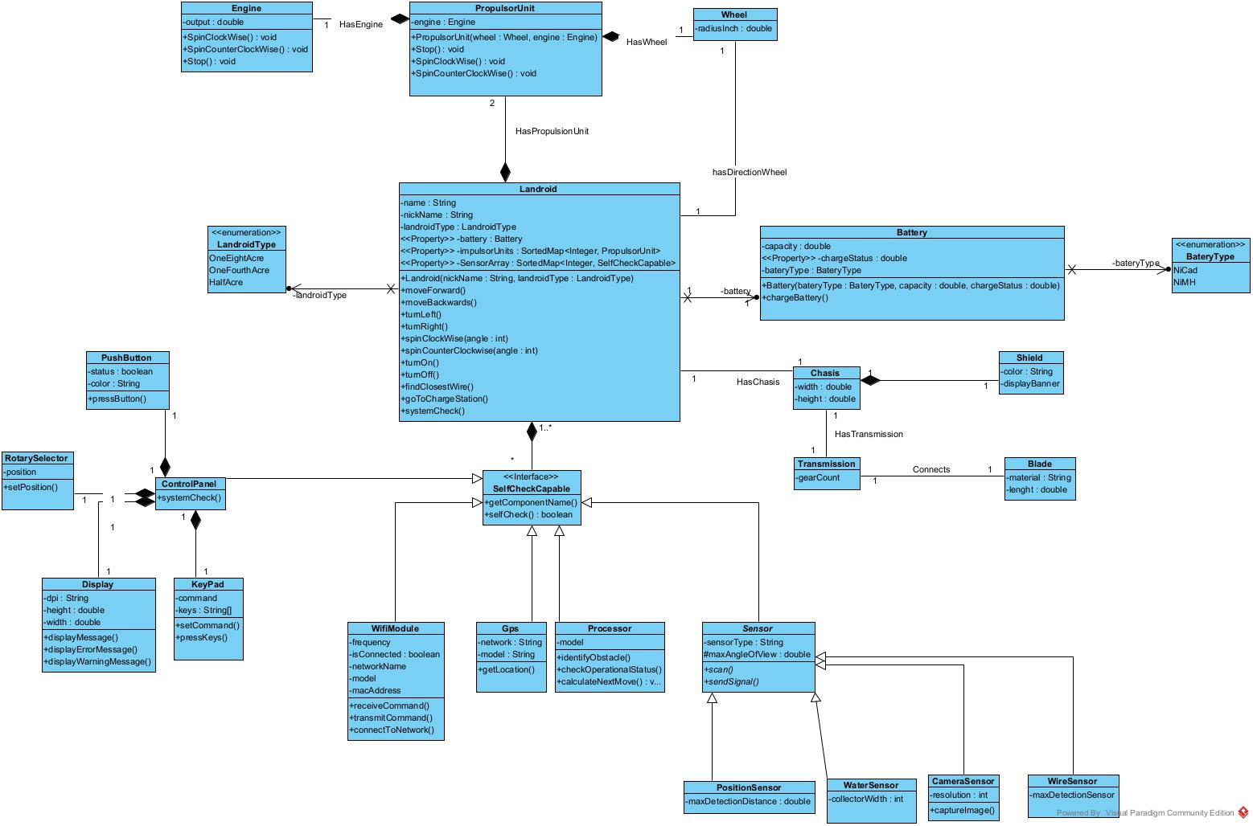

Image 1 Landroid Class Model